
North Bengal International University

Lab Report: 01

Exp Name : Linear search & Binary Search Algorithms

Subject : Analysis of algorithm Sessional
Subject Code : CSE 3111

Submitted By:
Name : Md. Tanvir Rahman Pranto
Dept : CSE(26)
Roll : 0712340012101005
Semester : 3rd Year, 5th semester.

Submitted To:
Name : Afsana Tasnim
Designation : (HOD)Lecturer
Dept : CSE
Date :

Task No: 01
Task Name: Linear search
Introduction: Linear Search is the simplest searching algorithm used to find a particular element in a list or array. It works by checking each element one by one from the beginning until the desired value is found or the list ends
Algorithm:
- Start from the first element of the array.
- Compare the current element with the target value.
- If it matches, return the index (or position).
- If it doesn’t match, move to the next element.
- Repeat steps 2–4 until the end of the array.
- If the target is not found, return a Not found

Pseudocode:
START
READ n
READ array[0..n-1]
READ key

FOR i = 0 TO n-1
IF array[i] == key THEN
PRINT "Found at position", i+1
STOP
ENDIF
NEXT i

PRINT "Not found"
END

code:
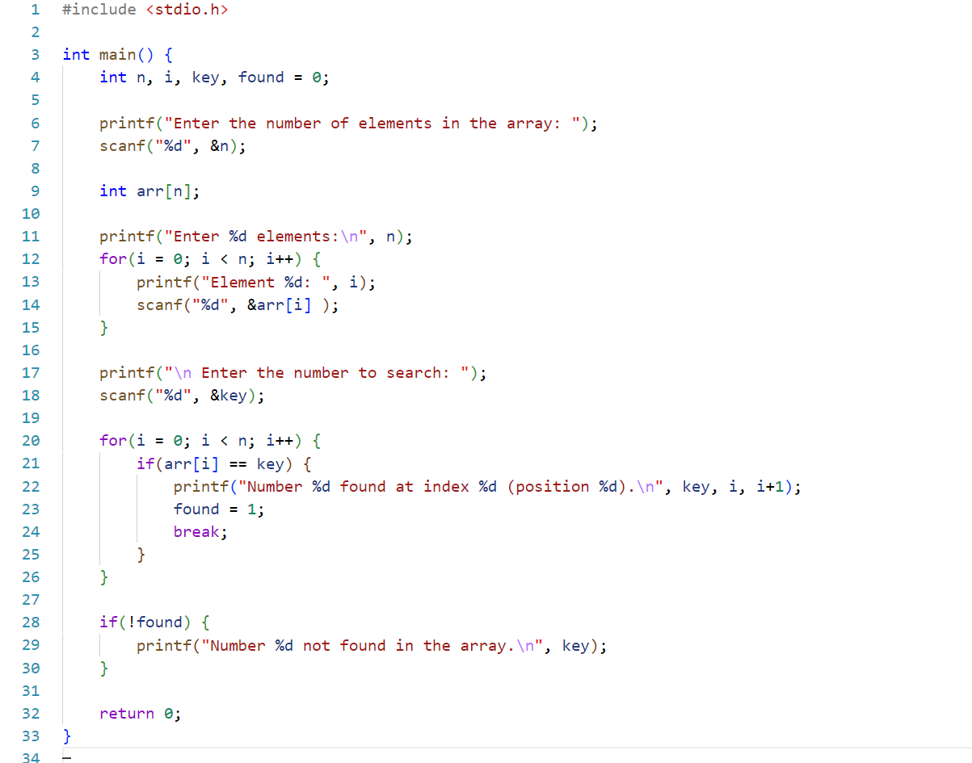
output:
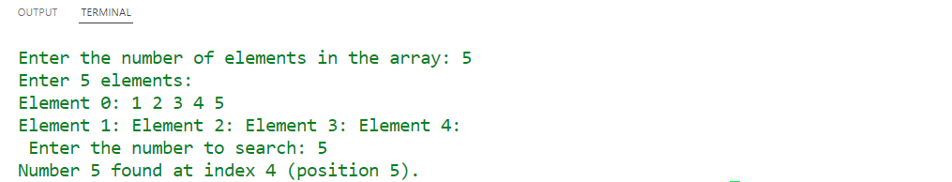

Task No: 02
Task Name: Binary search
Introduction: Binary search is a fast way to find a value in a sorted array (ascending order).
It repeatedly halves the search range by comparing the middle element with the target.
Algorithm:
- Read n (size of array) and the n elements in ascending order.
- Read the target value x.
- Set low = 0, high = n - 1.
- While low <= high:
- Compute mid = low + (high - low) / 2.
- If A[mid] == x: found → stop.
- Else if A[mid] < x: search right half → low = mid + 1.
- Else (A[mid] > x): search left half → high = mid - 1.
If the loop finishes without finding, x is not found.

Pseudocode:
low ← 0
high ← n - 1
foundIndex ← -1

WHILE low ≤ high DO
mid ← low + (high - low) / 2
IF A[mid] = x THEN
foundIndex ← mid
BREAK
ELSE IF A[mid] < x THEN
low ← mid + 1
ELSE
high ← mid - 1
END IF
END WHILE

IF foundIndex = -1 THEN
OUTPUT "Not found"
ELSE
OUTPUT "Found at index " + foundIndex // 0-based index
END IF

Code:
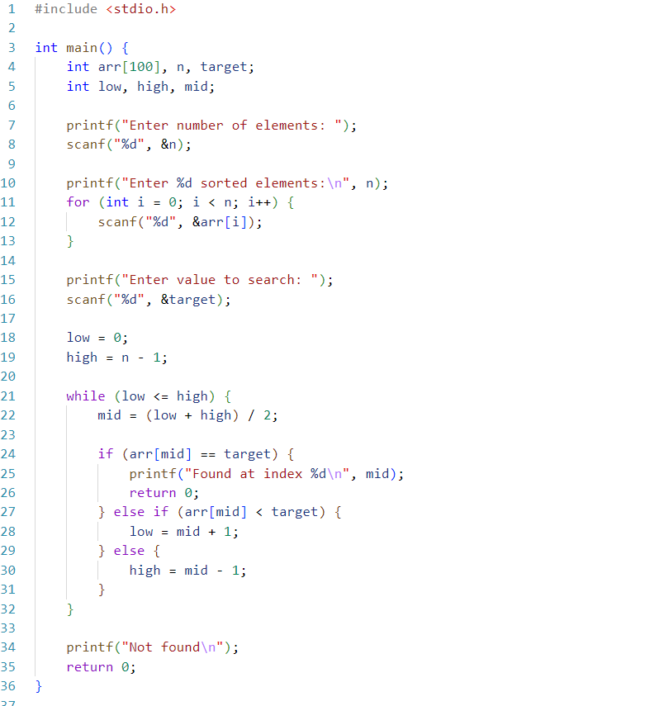
Output:
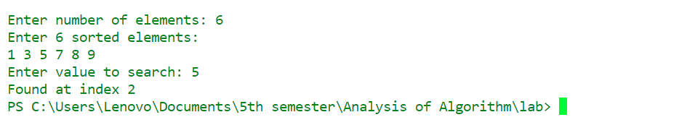
Conclusion: Conclusion: Linear search checks each element one by one and works on unsorted data, but it's slower for large arrays. Binary search is much faster with a time complexity of O(log n), but it only works on sorted arrays. So, use linear search for small or unsorted data, and binary search when speed matters and the data is sorted.

